Final Project:
ObjectDraw
Development Plan

April 10th 2009
Group One
Joseph Trapani
Ben Helppi
Satpreet Singh
Mark D'Souza
Amanda Parker

Contents:

A. Process Model
B. Iterations Planned
C. Schedule Planned
D. Tools & Configuration Management
E. Roles & Responsibilities

A: Process Model

- Iterative / Incremental development
- Incremental design with short stages is ideal for a month-long project
- Establishes working builds at the end of each iteration
- Build upon previous framework to expand scope
- Conducive to teamwork, and modularization will be introduced in later iterations after the basic framework is established

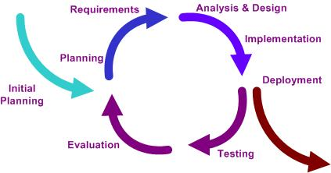
- Cyclic development
- Modifications will fit into simple modules
- Each iteration should analyze goals and reassess iteration plans if necessary
- Each iteration cycle has distinct phases with specific goals.

B. Iterations Planned

Iteration 1:
- Understand underlying technology
- Connect to another peer; (use old GUI)
- Pass an object over network; Acknowledge reception of object in some way;

Iteration 2:
- Establish a hierarchy of objects sent over network
- Acknowledge reception and recognize object received

Iteration 3:
- Setup networking model (how we send/receive events, canvas, objects, etc.)
- Make new GUI supporting collaboration
- Make canvas receive a session “owner’s” canvas in real-time
- Display network object feedback on chat window (layered event feedback)
- (Optionally) Make P2P chat work

Iteration 4:
- Implement transfer of “ownership”
- Loading and saving session (canvas + objects)
- Dynamic tool loading
- Tool sending and receiving over network
- Network robustness/optimization

C. Schedule Planned

Iteration | Duration | Dates
Iteration 1 | ½ week | (Sun) Apr 12th – (Wed) Apr 15th
Iteration 2 | ½ week | (Thu) Apr 16th – (Sun) Apr 19th
Iteration 3 | ~1 week | (Mon) Apr 20th – (Wed) Apr 26th
Iteration 4 | ~1 week | (Mon) Apr 27th – (Sun) May 3th
Buffer time | ½ week | (Mon) May 4th – (Wed) May 6th

D. Tools & Configuration Management
Tools being used:
- Programming Language: Java
- Programming IDE: Eclipse
- Documentation: MS Office and to a small extent, Google Docs
- Project Hosting provided by Google Code
- Configuration Management tool: SVN (via. Google Code)

E. Roles & Responsibilities

- Ben : Liaison, Architecture & Communication models, Implementer/tester
- Joe: Technical documentation control, Implementer/tester
- Amanda: Non-technical documentation control, Implementer/tester
- Mark: Implementer/tester
- Satpreet: Implementer/tester

